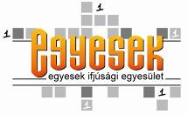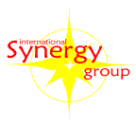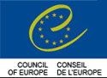

Learning to Participate

2-13 May, 2009., Hollókő, Hungary

- Information letter –

Contents

1. About the training 2
…themes 2
…target group 2
…purpose 3
…approach and method 3
…program elements 4
…team 5
2. Practicals 6
…dates 6
…venue 6
…what to bring 6
…costs 7
…visas 7
…applying 8

Attachments
Application form 9
Training method 12

1. What

themes

The themes of this training are:
- human resource development of youth NGOs and project teams: Volunteer management and community development as background of participation projects.
- personal development and empowerment of people working in NGOs and youth projects
- sharing innovative forms of active participation of young people and youth NGOs;

target group

The training is for young people, members, volunteers, leaders, coordinators, peer educators, professionals

Learning to Participate is a training for young people who are
- actively involved in the life of their of their communities, e.g. members of informal groups, action groups, youth leaders, peer educators, youth workers, teachers, members of NGOs, informal groups, student associations, young workers of local councils and other local decision-maker bodies, multiplyers of NGO networks.
- actively involved in the background work of participation projects and / or the long-term running of youth NGOs that deal with participation projects.

Countries:
Ukraine, Croatia, Slovakia, Serbia, Romania, Azerbaijan, Turkey, Bosnia & Herzegovina, Kosovo, Lithuania, Armenia, Latvia, Italy, Spain, Sweden, Greece, Portugal, the Netherlands, TFYROMacedonia, Hungary

All Council of Europe member states are eligible – in case your country is not listed above and you want to participate, please contact the organisers.

We can have 1-2 participants / country, in total 25.

Age limit: 16-30 years

We will ensure the geografically equal coverage, gender balance, cultural-, national-, age-, social background- and experience-based diversity of the group.

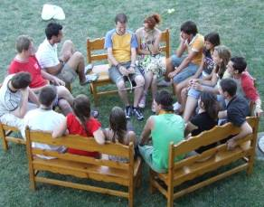

purpose

The purpose of the project is to strengthen the human resources of youth NGOs, informal groups and project teams, focusing on the following:

- Sharing innovative, creative approaches and techniques of participation.
- Adapting methods to the needs of the local communities and to learn to create new ones.
- Developing the human resources of youth NGOs on professional and personal level.
- Creating action plans for local participation projects and the human resources capacity building of the sending organisations.
- Mapping the opportunities of international cooperation between local communities through the participating NGOs.
- Giving personal experience and knowledge as well as providing the space to share best practice of participants

Approach and method

This will be a personal development and awareness training.

Participation and active citizenship, at the end are all about people, about you. Learning from each other, also when the other comes from a different cultural background, also starts with you. By cultural we also mean now different organizational cultures, local cultures and individuals. Without the individual, without you, they are all only beautifully sounding ideas. And when we come to putting them into everyday practice they can become very personal…

This is why we chose to approach these themes from the personal angle, in a training where the focus will be on you, the individual. This will be an individual training in a group context where we will invite you to ask yourselves the questions: “How do I participate in my own life?” “How do I handle people?” “How do I handle differences and diversity?” “ – and many more. Starting from here we will offer you the opportunity to see how you function in a group and how a group functions with you. We will connect the experiences and theories to everyday practice: we will ask you to connect what you experience in this group to what you experience back home in your organisation. Then you, the participants will get the space to work with each other, share experience and best practice, give input and support each other to get the most out of the program.

For us it is also important that you implement what you learn inside the training as well as outside of it, back in your sending organization or in your local communities. So we will create a lot of different situations and contexts, to offer you the chance to practice, test and experiment with the themes, reflect on your experience, to learn from yourself and from each other.

We will use the methods of learning by experience, coaching and intercultural learning.

You can find more about the training method in the attachments.

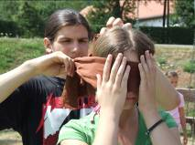

Program elements

We will put equal focus on personal and professional development. The final program will be planned based on the needs survey of applicants – so it is very important that you take time to answer the questions of the application form. This is your chance to inform us about what you want to learn.

In the personal development parts we will cover topics such as responsibility, participation, initiative, cooperation, leadership, diversity, handling prejudice, communication, listening, self-expression, creativity, decision-making, feedback, motivation, personal and common goals and values.

For professional development will cover tools for project management and local community development: surveying needs, goalsetting, action planning, organising, handling human resources, working with young volunteers, methods of support and empowerment, methods for involvement of local decision-makers, inclusion of less-opportunity groups.

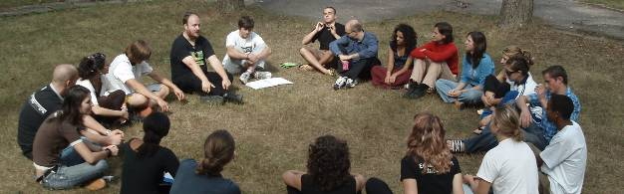

Participants get the space to share knowledge and learn from each other. They will do workshops and presentations on participation and volunteer management methods, work out new methods in intercultural teams.

We will also practice how to transfer knowledge into a new context: this time in the challenging context of an outdoor training, where participants perform complex project-like tasks to practice teamwork, creativity and develop their personal skills as a young leader.

At the end of the program there will be time for summarising what participants learned, drawing transferrable, practical conclusions, creating action plans and project proposals for the future, planning the follow-up where participants will multiply the methods in their own organizations, final evaluation and closing.

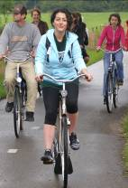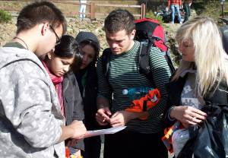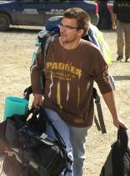

The program and the schedule will be intensive.

During the 7 days of the training we will have a full schedule:

8:00 Breakfast
9:30 – 12:45 Program
13:00 Lunch
14:30 – 17:45 Program
18:00 Dinner
19:00 – 22:30 Program

Length of the progam parts, starting and finishing times will vary according to the actual content, like in case of off-site program parts, like part 2 and 3, this can look different.

There will be lectures, processes and sharings.
Information, theories, tools and techniques will be given in lectures.
Practice will be done in so-called processes, they are individual, couple or group assignments or exercises, that we will do. They will be followed by debriefing.
Debriefing will be done individually, in pairs, in smaller groups and in the big group, too. This is what we call „sharings” when you share your experience, your insights, your questions with each other and with the support of the trainer or the team members you work with them.

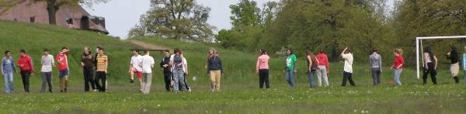

Team

The trainers will be Krisztina Győry and Diána Hajdu-Kis.
They both work as trainers of the International Synergy Group, Diána is also a member of the Council of Europe pool of trainers. They are active in the human resources development process of Egyesek, the organiser, and work with several other NGOs and also business companies in Hungary. Presently they run trainings for youth coaches.

The trainers and the participants will be supported by an international team of 7 volunteers, who have done a similar program before and have experience int he themes of the training.

2. Practicals

dates

Arrival to Hollókő till: | Any time | 2nd May
The program starts: | 10:00 | 3rd May
The program finishes: | 22:00 | 12th May
Departure day: | Any hour you need. | 13th May

We expect you to participate in the whole training!
(That is, coming later or leaving earlier than the times given above is not allowed.)

You organise your own travel to the project venue, also in Hungary between Budapest and Hollókő.

We are asking you to arrive on the date given above, by the given hour to the accommodation.

Panoráma Panzió, Hollókő, Orgona str. 31.

Foreigners:
Arrange your flight dates and times in a way, that you can make it.
If you need to arrive in Budapest 1-2 days earlier or leave later, to be able to be in Hollókő in time, arrange your own accommodation for the extra time. Let is know if you need assistance with it.

Hungarians:
The condition to your participation is that you do some volunteer work for the project: you organise your life in a way that you are able to support the foreign participants before and after the training with organising their accommodation, food and transfer between Budapest and Hollókő on time.

venue

The venue of the training will be the a youth accommodation and guesthouse.

Address: Panoráma Panzió, Hollókő, Orgona u. 31.
There is no phone or internet connection.
The number here is the private phone of the owners, where you can be contacted in case of emergency: 00 36 32 379 048
There is no washing machine either, you can handwash.

what to bring

- Towel
- Camping matress
- Sleeping bag till -4 degrees C.
- Warm and comfortable clothes for outdoor & indoor
- Clothes that are OK to get dirty during outdoor activities
- Backpack
- Water bottle
- Raincoat
- Good walking boots: waterproof, has strong soles and holds your ankle firmly
- Indoor shoes
- passport or other official identification
- copies of bills and tickets described below in the COSTS section
- insurance: it is your responsibility to have health and travel insurance
- Hungarians: TB card
- Your own medicines

Weather at this time of the year here is unpredictable – there can be any heat from freezing till +30C. Nights are surely cold still. There can be rain, too.
costs

Egyesek covers the following costs:
- accomodation
- food
- the costs of the training programme

For these we received grant from the European Youth Foundation.

Participants cover the following costs:
- Travelcosts from your living place to the project venue.
- Insurance
- Visa costs

Registration fee:

Participants from EU: 80€ / person

Participants from outside EU: no registration fee

visas
(this part is only for those who need a visa to enter Hungary)

You give us all the data requested in the application form. If you are selected, you receive a confirmation letter from us. From this moment we need you to check your mail regularly and be ready to provide information in case it is needed.
We start the official visa procedure, step by step as required by the Hungarian law:

- We submit your personal invitation request to the Immigration Office. The costs of the procedure in this office is covered by Egyesek.

- The Immigration Office takes 1 month to approve your invitation. During this time you need to find out the following:
- Which Hungarian embassy handles your visa request
- Get and fill in all the forms you need
- A support letter from your sending organisation.

- They issue your invitation.

- Egyesek sends your invitation to you by registered priority mail. In case there are more than 1 participants from your country we will send all the invitations to one of you or to one of your sending organisations. We will also send you a scanned copy of it by e-mail.

- As soon as you receive the Official Invitation Letter, you submit the visa request to the Hungarian Embassy. Visa costs that you need to pay at the embassy are covered by you.

The whole procedure should take between 6 – 10 weeks.

Applying

Please find the application form in the attachment.
Send the filled-in forms back to Lina, to the following address:

learning2participate@gmail.com

Lina is the contactperson of the organiser team, please write to her also if you have any questions.

Deadlines:

1st of February for applicants from outside the EU.

1st of March for applicants from the EU.

Participants under 18 must also send and bring the parents’ consent form.

We are looking forward to welcomr you in Hollókő,

Learning to Participate team
Egyesek Youth Association

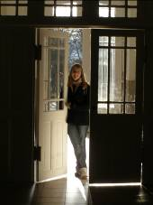

APPLICATION FORM

LEARNING TO PARTICIPATE
Basic synergy training

2nd – 13th MAY 2009, Hollókő, Hungary

To be sent to learning2participate@gmail.com

1st of February for applicants from outside the EU.

1st of March for applicants from the EU.

Personal data
!Please give personal data the same way as they are standing in your passport!
 | First name:
 | Second name:
 | Date and place of birth:
 | Mother”s name:
 | Street:
 | city:
 | region:
 | postcode:
 | phone:
 | e-mail:
 | Occupation or profession:
 | Special Diet:
 | What is your present health condition? Detail health problems and their present state. Specify and describe any medication you take or have taken within the last 6 months
Contact person in case of emergency
Full name:
Address:
Phone numbers:
Relationship to you:
 | Level of English: (bad, medium, good, excellent)
 | How did you find out about this training?
 | Sending organisation
 | Name of organisation
 | address
 | website
 | e-mail
 | phone
 | Contactperson’s name and function
 | What is your role in the organisation
II. rész: Training needs survey
Why are you interested in this training? How are you connected to the themes? (20 – 50 words)
What personal skills do you want to develop?
(20 – 50 words)
What results do you expect concerning your personal development?
(20 – 50 words)
How do you assess your knowledge concerning  Handling human resources:  Youth participation projects:  (1 lowest, 7 highest) |  | 1 2 3 4 5 6 7  1 2 3 4 5 6 7
What is your knowledge and experience that you want to share with the rest of the participants?
(20 – 50 words)
What do you want to learn during the professional parts – mention themes as well as skills, questions that you find relevant concerning yourself and/or your NGO? (20 – 50 words)
What results do you expect concerning your personal development?
(20 – 50 words)

By submitting this application I, the undersigned, confirm that I have read and understood the Information Letter about the training LEARNING TO PARTICIPATE and I know and accept the conditions of participation.

Place:

Date: Signature:

Parents’ consent

If you are under 18 years old, you need to bring the original of this form with you to the training.

I, the undersigned ______________________________________________________ (name of parent),

Have received all information about the training LEARNING TO PARTICIPATE

taking place from 2nd – 13th MAY 2009, in Hollókő, Hungary

And i agree that my daughter/son, _______________________________(name of participant)

participates the training.

place:

date: signature:

TRAINING METHOD of the International Synergy Group

Learning to play, playing to learn

Learning by experience, outdoor training, and theatre plays are working methods which all have one thing in common: playing. Playing allows us to access a state of freedom, creativity and exploration that is associated with the natural learning of childhood. Roleplays, structured experiments, simulation, and theatre are examples of games with experiential learning opportunities. Games can create a play frame, which makes the act of learning a dynamic and enjoyable process, which recalls the carefree playing time of childhood.

Experiential activities can transform learning into adventure. Learning in this way is an emotional, physical as well as a cognitive experience. Movement and feelings stimulate the learning process. Playing involves both mind and body and can provoke an emotional response during the exercises. The exercises are designed to use social skills and make clear / illustrate concepts and theories. Almost any topic can be explored through games. Learning processes that involve the development of skills and behavioural change, such as group dynamics, communication, leadership, problem solving, teamwork, coaching, co-operation and decision-making are very suitable for gaming.
Gaming is a working method which might create a paradoxical situation in which participants or a group might loose themselves. The objective of using gaming in this kind of training is to get more knowledge and skills to work with groups in the field of youth work and social work.

Although this working method may seem enjoyable, it is not "only a game". It allows the players to use the freedom to experiment with new approaches and new behaviour and to acquire skills and knowledge. The players are asked to look at how they behave in the play. Therefore feedback and reflection are an essential part in this way of working. Playing games as a tool for learning is a serious play or 'playful seriousness'.

The Olde Vechte Foundation has developed this working method in a specific way. Since the founding of the "Olde Vechte" foundation in 1966 we used a group accommodation for the training- and education activities. Working with groups in a hostel situation became part of the working method.

Our training method is based on learning by experience. In our approach we invite participants to point out where they find themselves at that moment in the learning process, what they want to learn and how they want to develop themselves. It is focused on the experience of the individual and it is connected to the specific needs and the level of learning of the participant at that moment. The programme is a tool for the participant and not the other way around. No matter how logical this may sound, in many formal learning situations the usual form of acquiring knowledge is 'learning from lessons'. The knowledge should be reproduced / copied by the student, without any personal interaction. 'Learning by experience' is different since it starts from the person him/ herself, his/here behaviour, reactions and emotions. This method is often used in youth work and informal education. And more and more this method is being used in formal education and trainings for companies.

The way, in which we like to organise and perform this international training, means that main objectives of the training have to be clear to the participants, as well as the outlines of the programme and the target group. In this way we create a playing field for participants and trainers where we can play to learn and learn to play.

Within the given group, you participate in the training for yourself and with yourself as an individual. The exercises (called ‘processes’ in our training context) will be done alternately alone, in pairs or in a group. The trainer will prepare the ground by giving plenary lectures. Some processes may involve talking, others listening or visualising certain thoughts with your eyes closed. Exercises will be provided in combination with music, dance or play. Many processes will contain an element of surprise, the exact nature of which is not known in advance. In this way questions can only be answered by the participant him/ herself, namely by experiencing his own reactions.
With this training approach there is room for the experiences and wishes of the participants to influence the content of the programme while it is taking place. We create the playing field and the participants make the play.

